Project Report

1. INTRODUCTION
   1. Project overview:

In this project, we created CRM application for retail shops to manage their stocks in the warehouse and check the availability .

We created a application, they are

* Sales app
* Sales app helps to store the records of the warehouse

1. Problem Definition and Design Thinking

2.1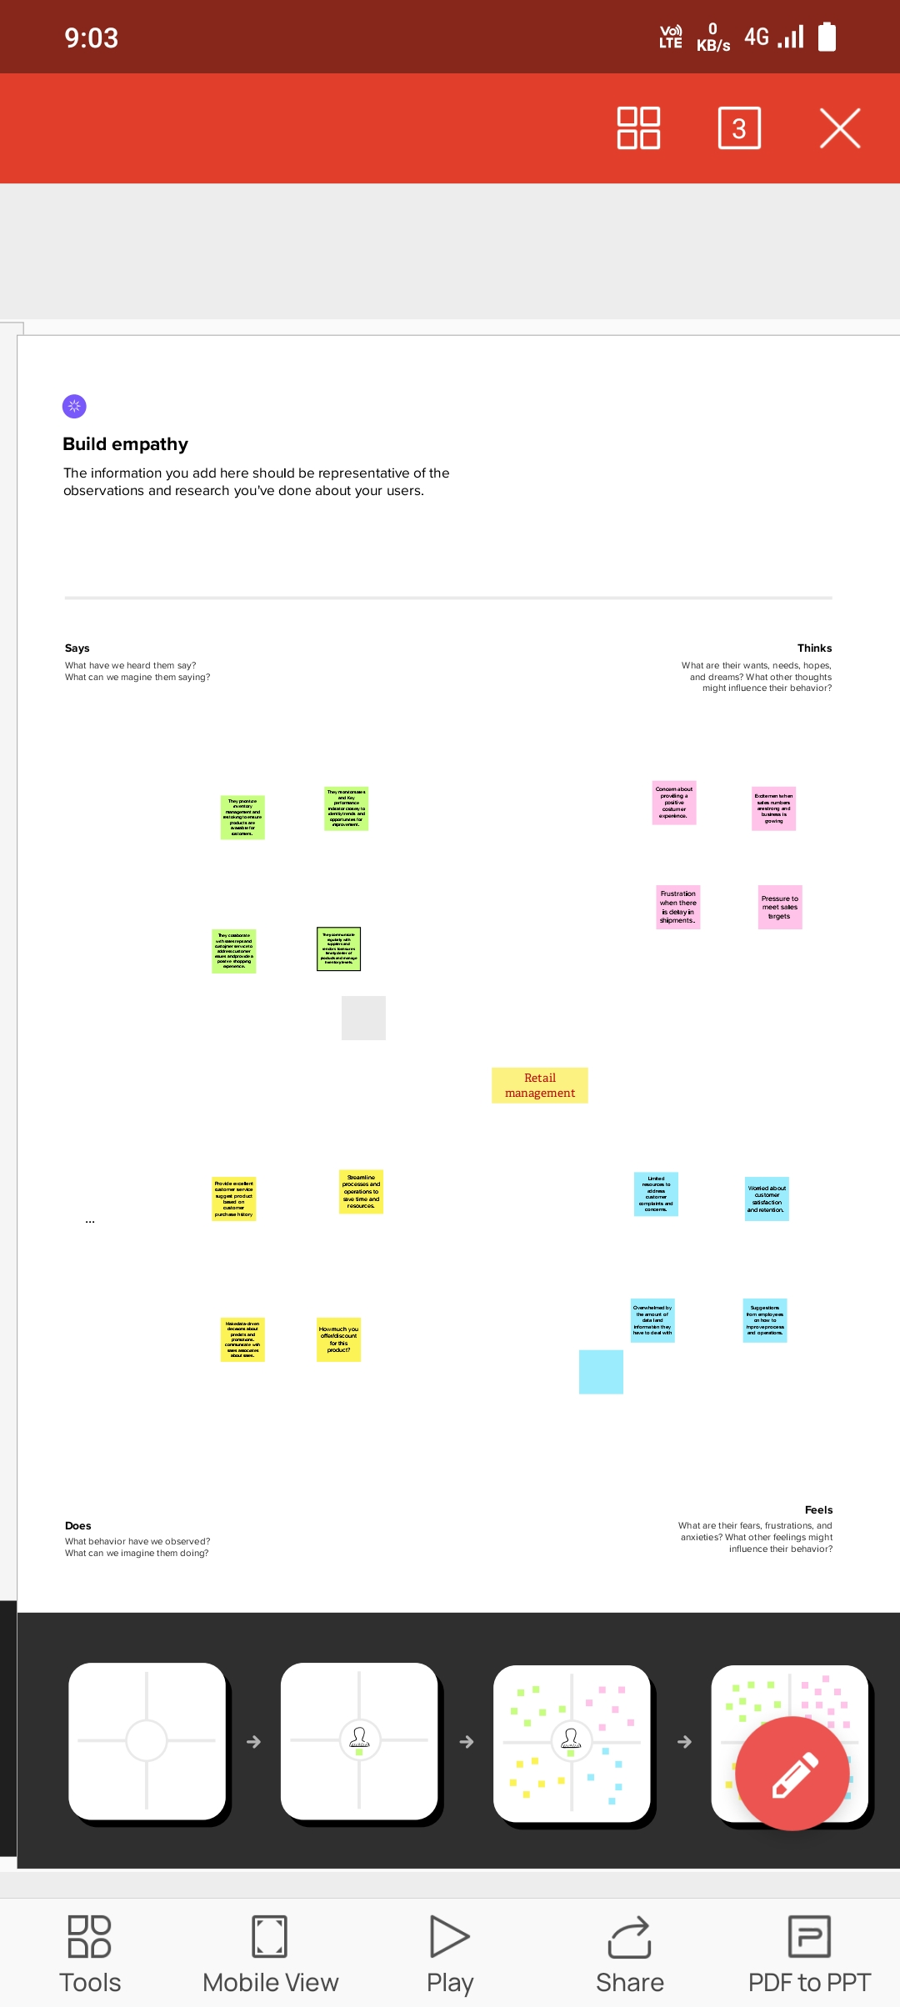 Empathy map :

2.2 Ideation and Brainstorming map:  
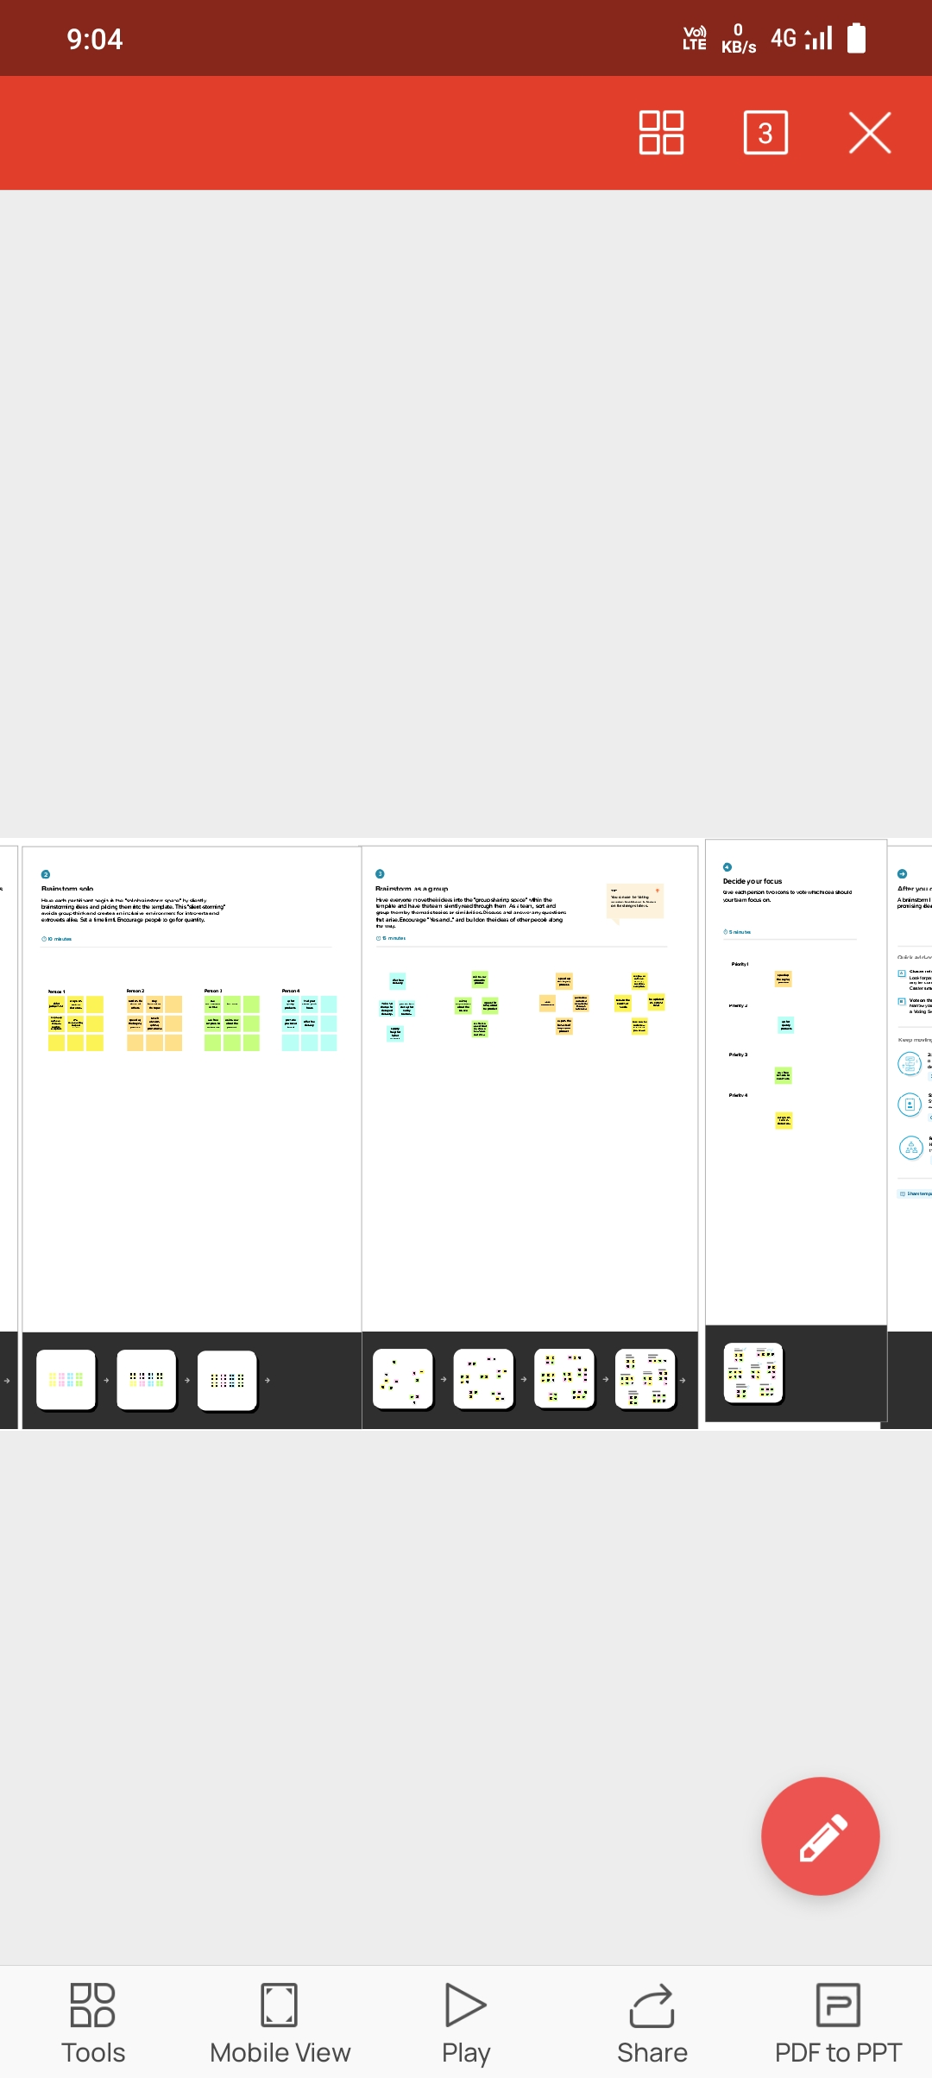

1. Result

3.1Data Model:

|  |
| --- |
| **Object name** |
| Campaign |
| Leads |
| Accounts |
| Contacts |
| Opportunity |
| Product |
| Ware house |
| Sales order |
| Dispatch and tracking |

3.2Activity and screen shots

Milestone 1:

Creating developer account

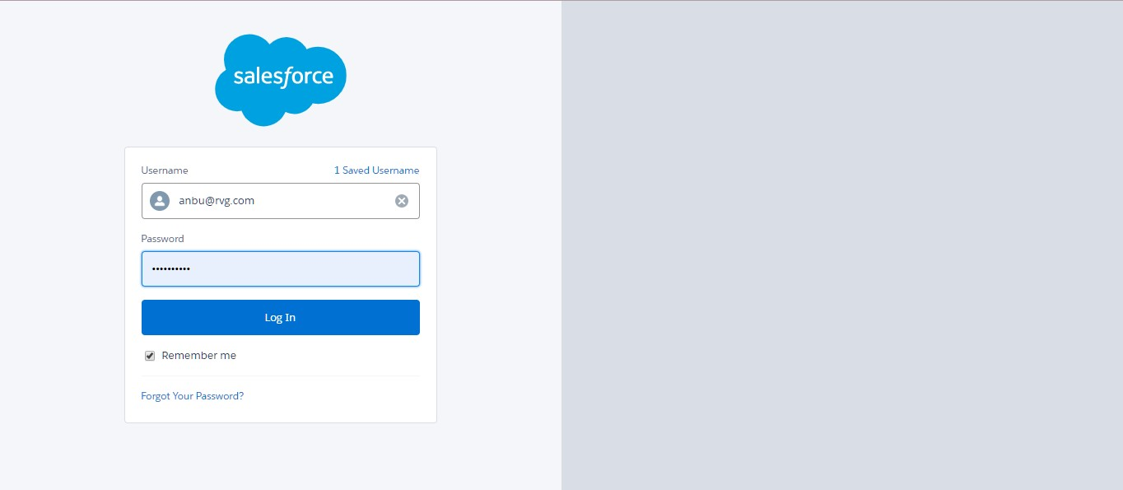

Milestone 2:

Activity 1- creation of objects in sales force

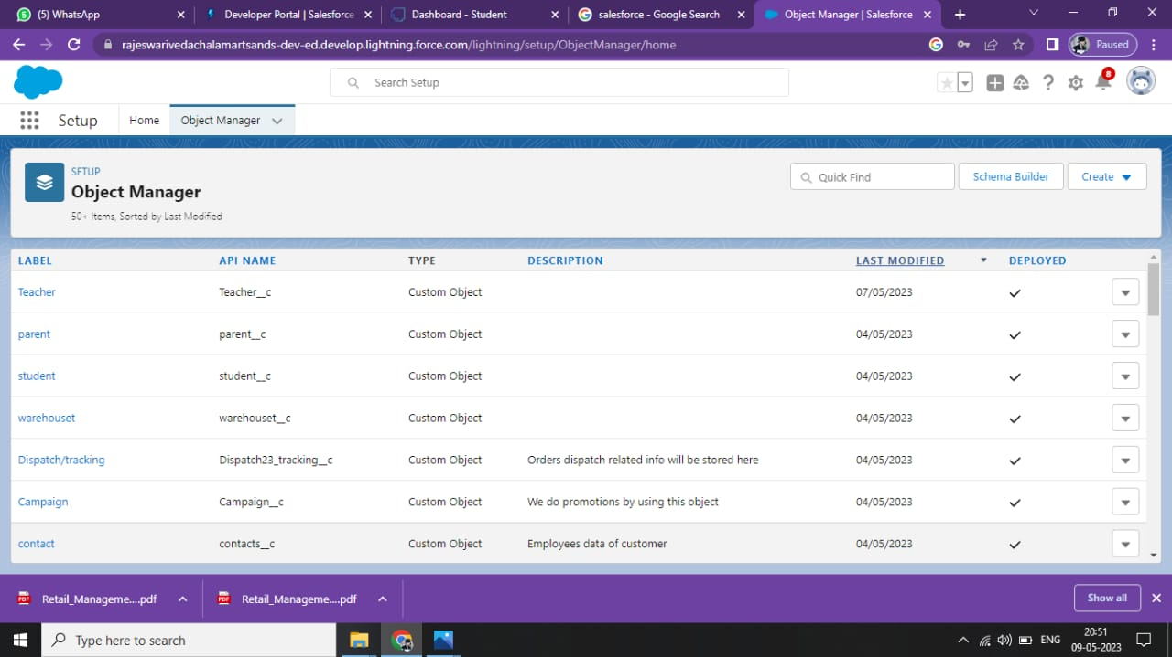

Milestone 3: creating relationship between objects

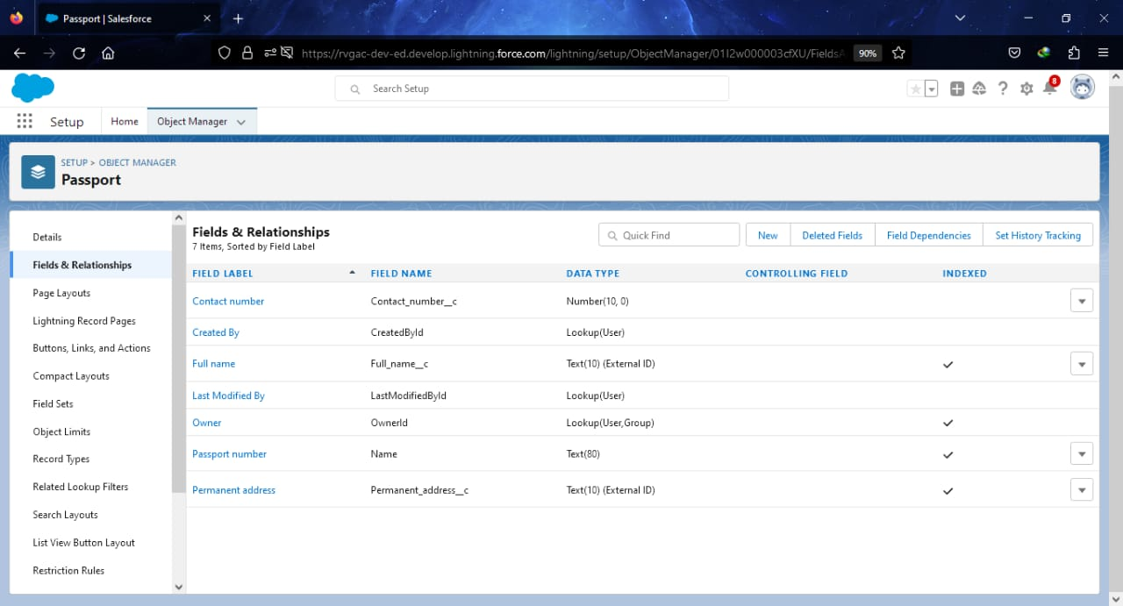

Milestone 4: Creation of Sales app using lightning:

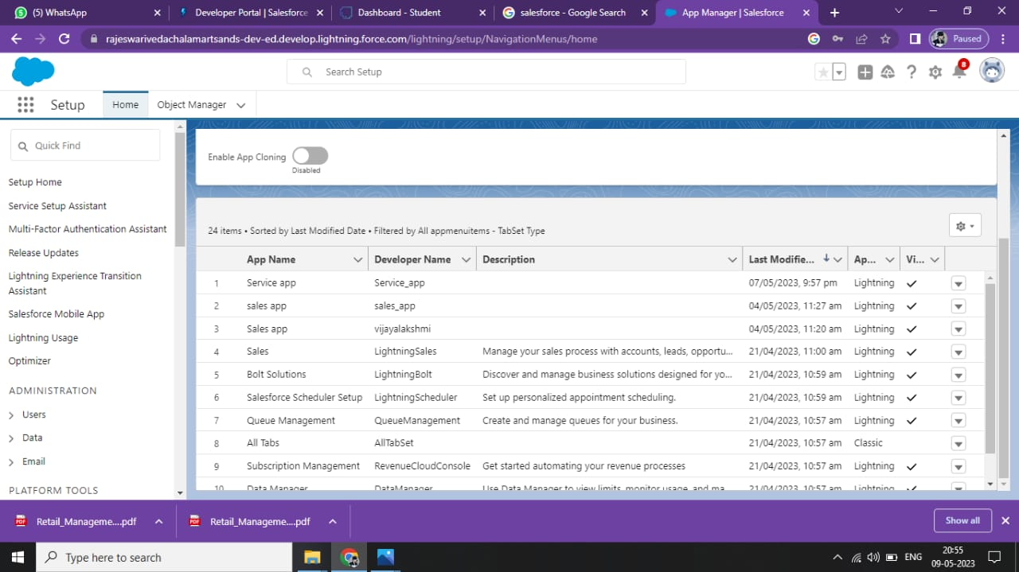

Milestone 5: Creation Of Layouts :

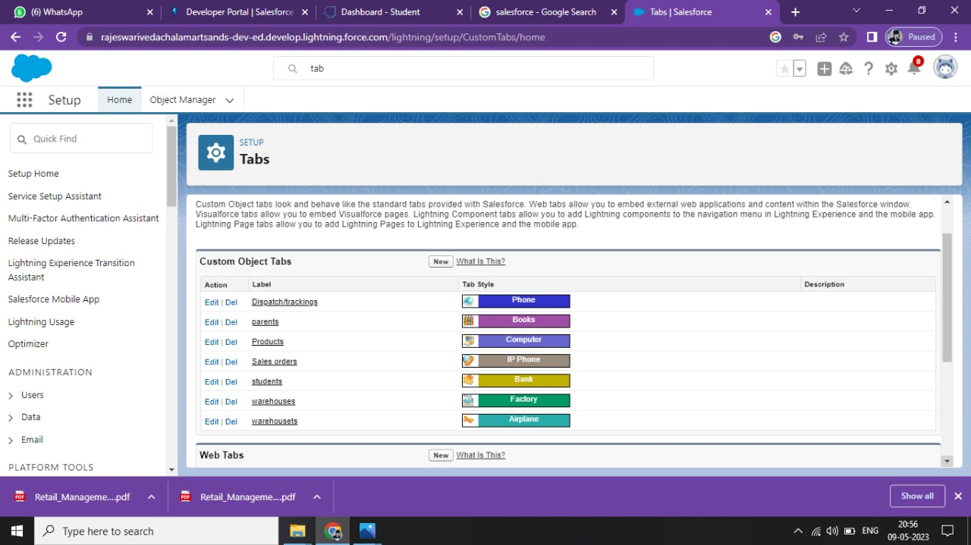

Milestone 6: Creation Of User:

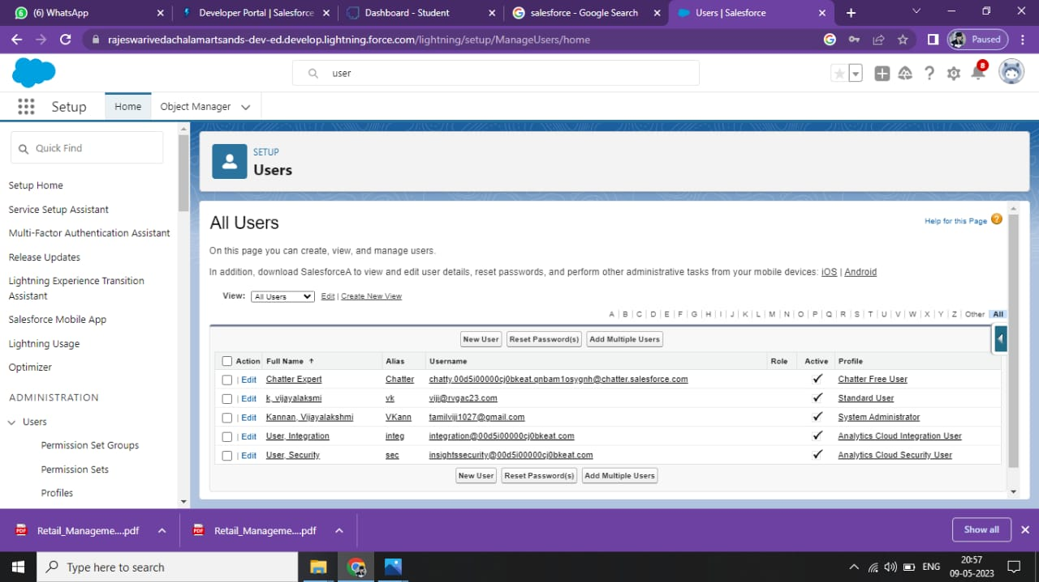

Milestone 7: Creation of Validation Rules:

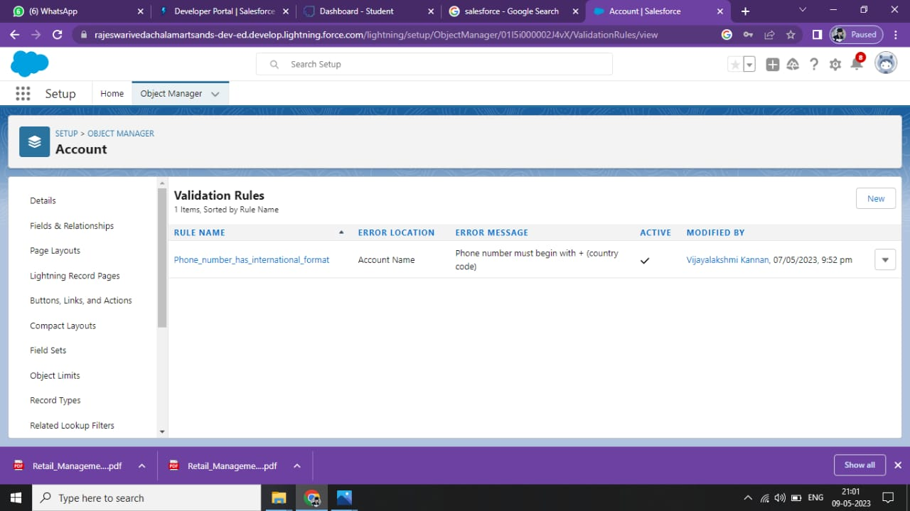

Milestone 8: Creation of Reports:

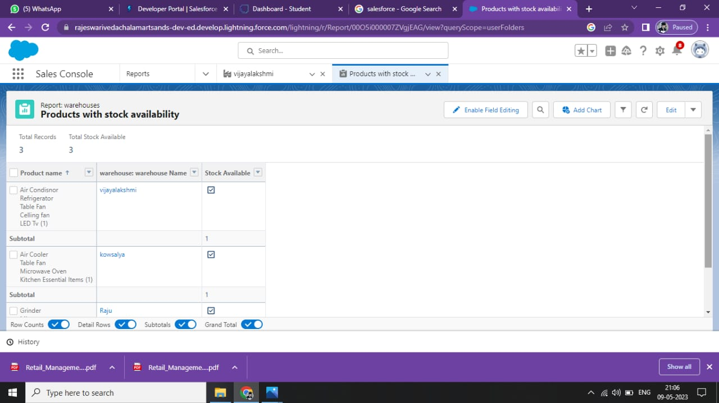

Milestone 8: Creation of Dashboard

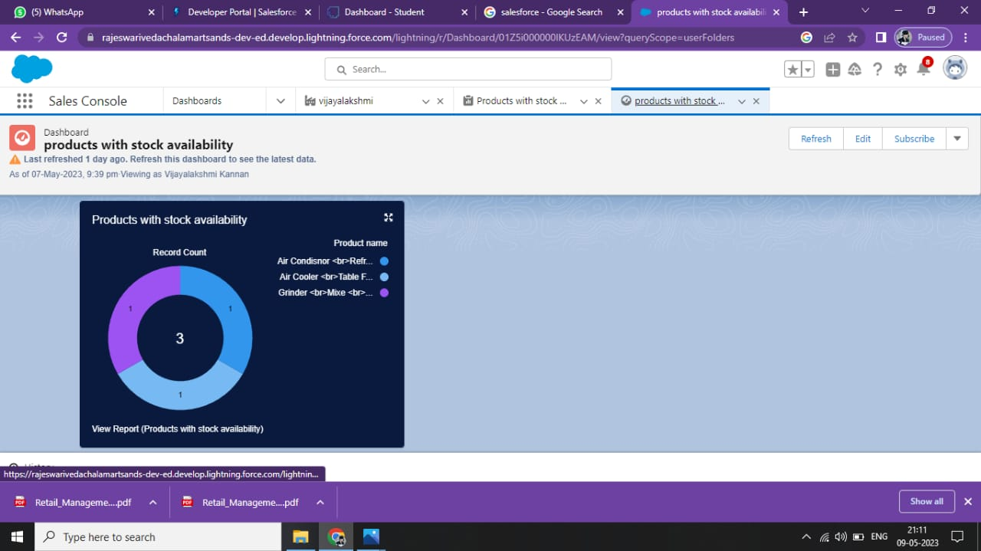

4. Trailhead Profile Public URL:

Team leader :

Team member 1:

Team member 2:

Team member 3:

5. Advantage and Disadvantages

In this Salesforce we created the app called sales app for the retail services Retailing encompasses the business activities involved in selling goods and services to consumers for their personal, family, or household etc

6. Application:

Our Apps is to be :

* All kinds of Retailers and stocks availability can be checked ,
* All type of Report Collecting Companies,
* Etc……

7. Conclusion:

We create the objectswith the help of Salesforce app. And also create a App(Sales App) with the help of Salesforce. And then the objects are converted to Fields and then permission sets. At last finished the creation of App.

8. Future Scope:

Ability to create a App.